Triangulation
# Source: AI Source: Provided by: [Data Path: Persons Table -> ID Column: 1, Name_En Column: Motasem Essam] -> From: [ChatGPT] on [7/25/2026]
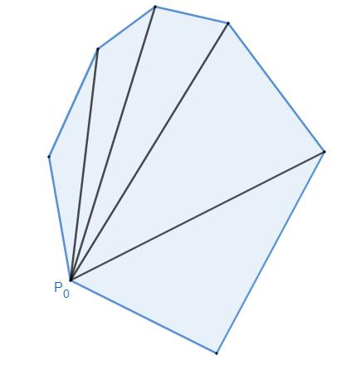
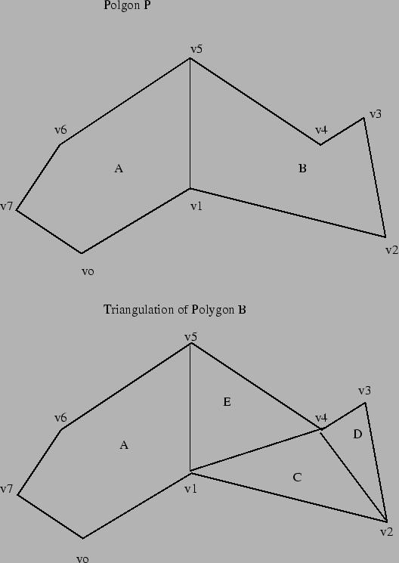
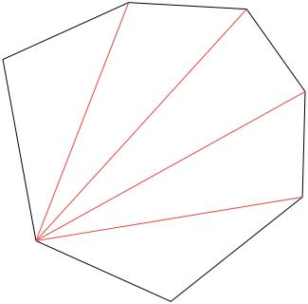
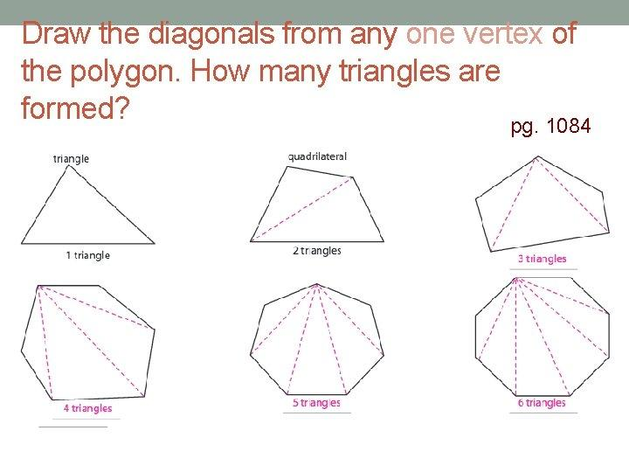

Definition
# Source: AI Source: Provided by: [Data Path: Persons Table -> ID Column: 1, Name_En Column: Motasem Essam] -> From: [ChatGPT] on [7/25/2026]
Triangulation is the process of dividing a polygonal region into triangles by drawing non-crossing diagonals between its vertices.
The resulting triangles:
- Completely cover the original polygon.
- Do not overlap in their interiors.
- Share only edges or vertices.
- Preserve the original boundary of the polygon.
For a simple polygon with $n$vertices, every triangulation contains:
$$\boxed{n-2}$$
triangles.

Purpose of Triangulation
# Source: AI Source: Provided by: [Data Path: Persons Table -> ID Column: 1, Name_En Column: Motasem Essam] -> From: [ChatGPT] on [7/25/2026]
Triangulation is used to:
- Divide complex polygons into simpler shapes.
- Calculate the area of polygons.
- Determine the sum of interior angles.
- Analyze geometric structures.
- Simplify geometric proofs.
- Support computer graphics and computational geometry.
- Create meshes for engineering and scientific applications.

Fundamental Concept
# Source: AI Source: Provided by: [Data Path: Persons Table -> ID Column: 1, Name_En Column: Motasem Essam] -> From: [ChatGPT] on [7/25/2026]
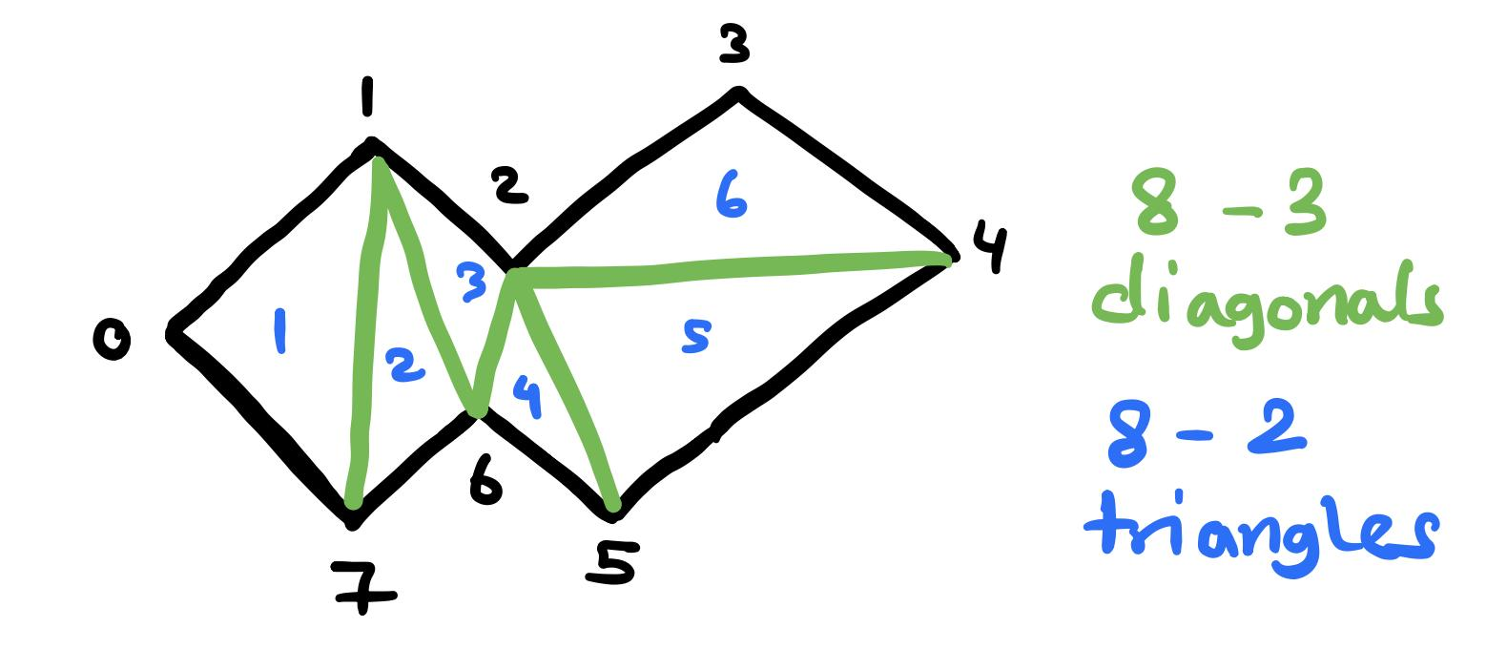
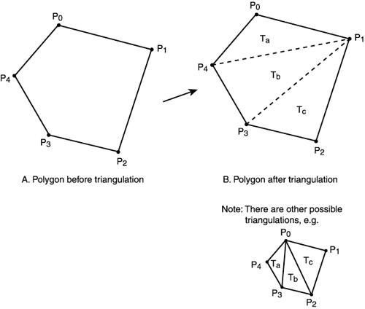
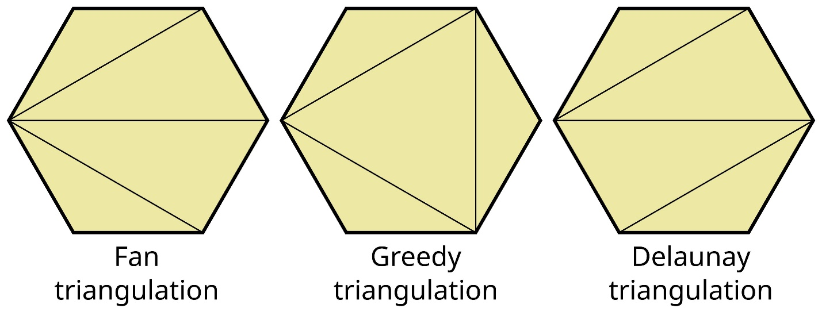
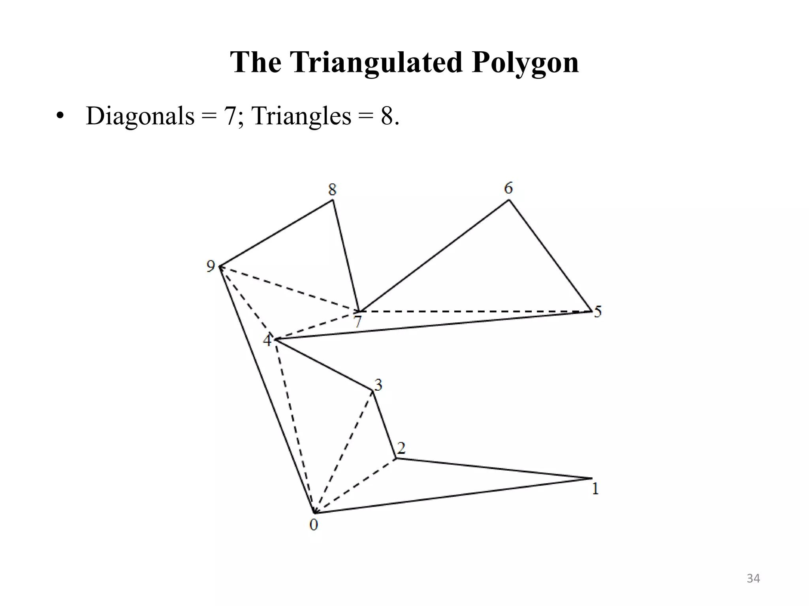
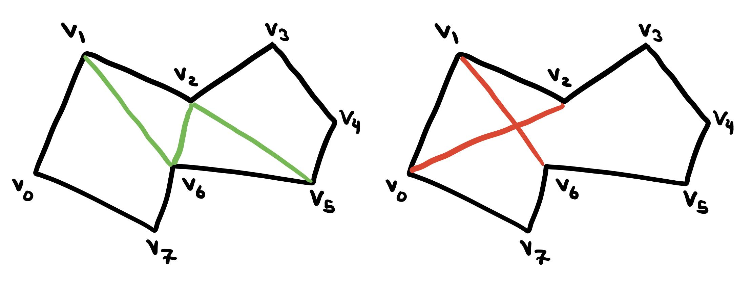
A polygon can be triangulated by selecting a vertex and drawing diagonals from it to suitable non-adjacent vertices.
For an $n$-sided polygon:
$$\boxed{\text{Number of triangles}=n-2}$$
The number of diagonals used in one triangulation is:
$$\boxed{\text{Number of diagonals}=n-3}$$
Therefore:
$$\boxed{\text{Triangles}=\text{Diagonals}+1}$$

Triangulation of Common Polygons
# Source: AI Source: Provided by: [Data Path: Persons Table -> ID Column: 1, Name_En Column: Motasem Essam] -> From: [ChatGPT] on [7/25/2026]
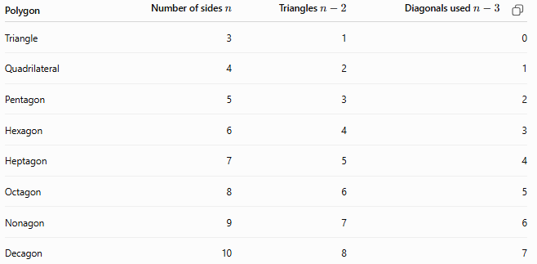
Polygon | Number of sides $n$ | Triangles $n-2$ | Diagonals used $n-3$
Triangle | 3 | 1 | 0
Quadrilateral | 4 | 2 | 1
Pentagon | 5 | 3 | 2
Hexagon | 6 | 4 | 3
Heptagon | 7 | 5 | 4
Octagon | 8 | 6 | 5
Nonagon | 9 | 7 | 6
Decagon | 10 | 8 | 7

Triangulation of a Quadrilateral
# Source: AI Source: Provided by: [Data Path: Persons Table -> ID Column: 1, Name_En Column: Motasem Essam] -> From: [ChatGPT] on [7/25/2026]
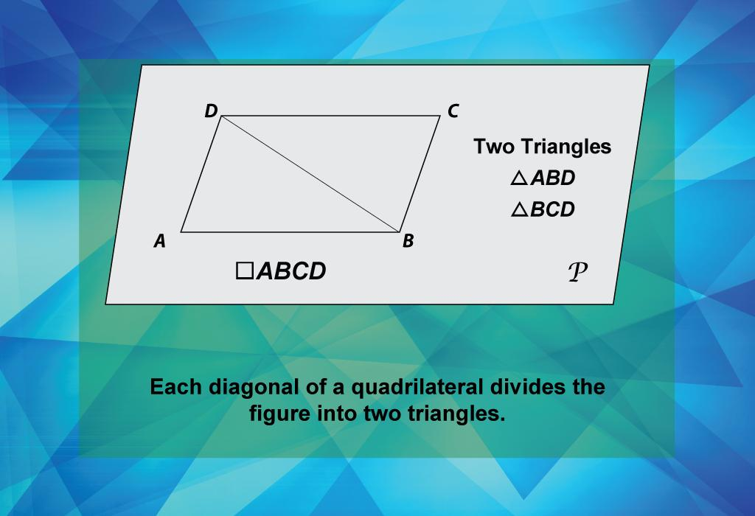
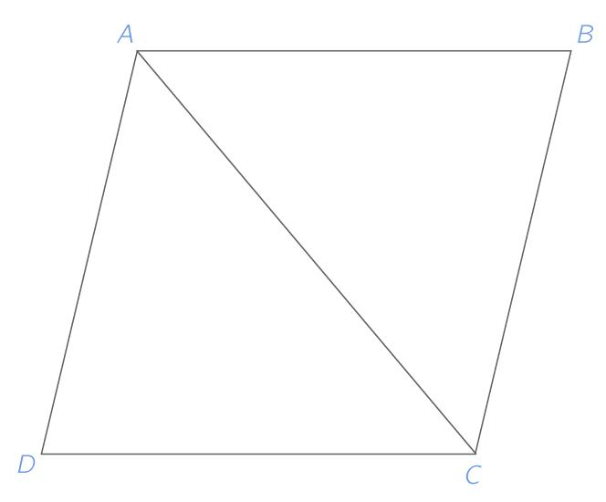
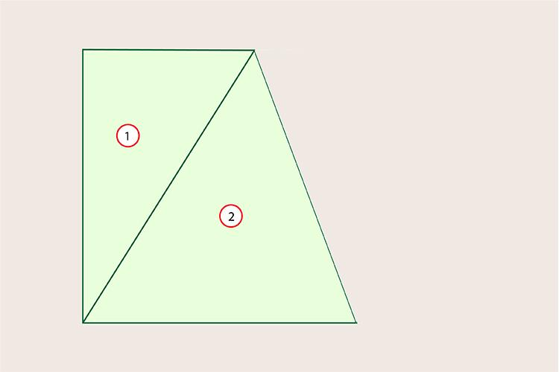
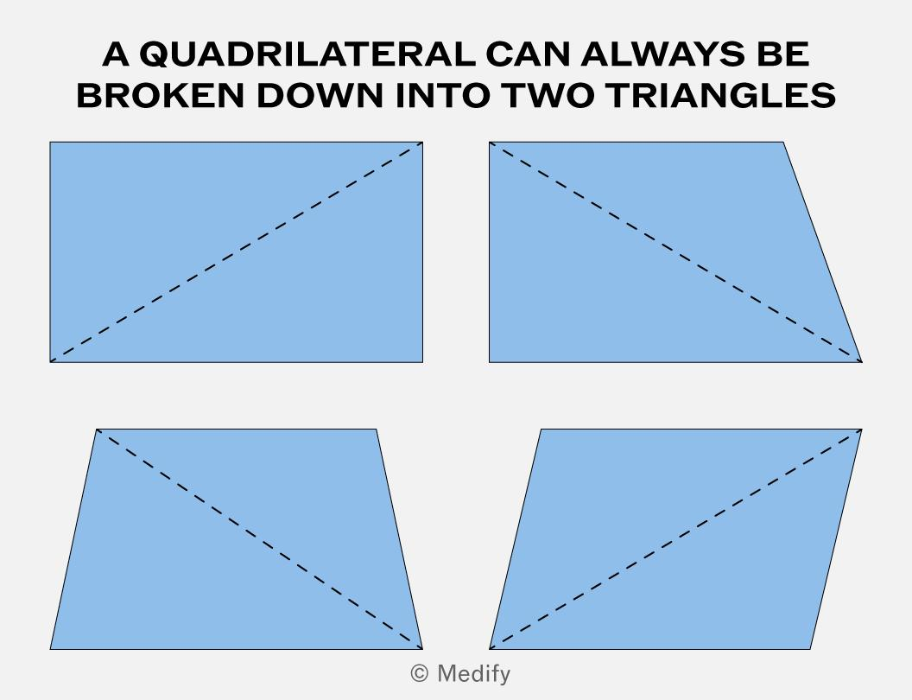
A quadrilateral can be divided into 2 triangles by drawing one diagonal.
$$4-2=\boxed{2}$$
Therefore, one diagonal is required:
$$4-3=\boxed{1}$$

Triangulation of a Pentagon
# Source: AI Source: Provided by: [Data Path: Persons Table -> ID Column: 1, Name_En Column: Motasem Essam] -> From: [ChatGPT] on [7/25/2026]
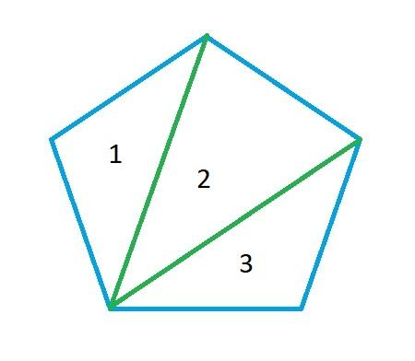
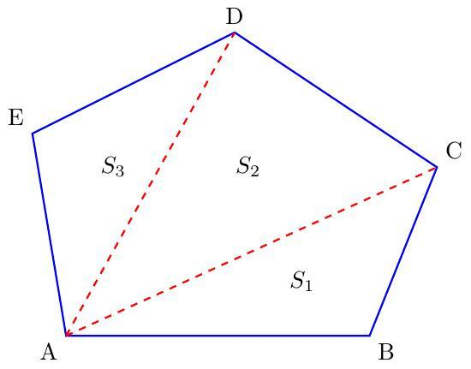
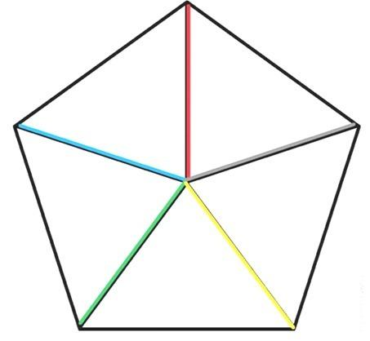
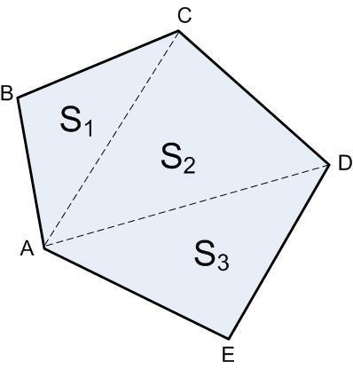
A pentagon can be divided into:
$$5-2=\boxed{3}$$
triangles using:
$$5-3=\boxed{2}$$
non-crossing diagonals.

Triangulation of a Hexagon
# Source: AI Source: Provided by: [Data Path: Persons Table -> ID Column: 1, Name_En Column: Motasem Essam] -> From: [ChatGPT] on [7/25/2026]
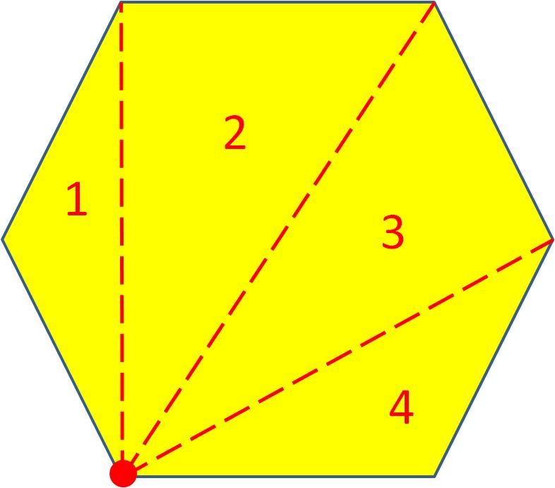
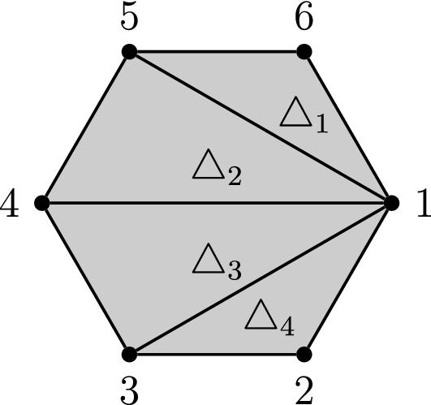
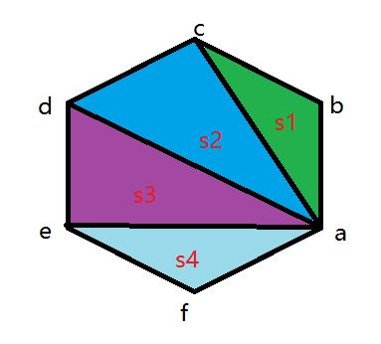
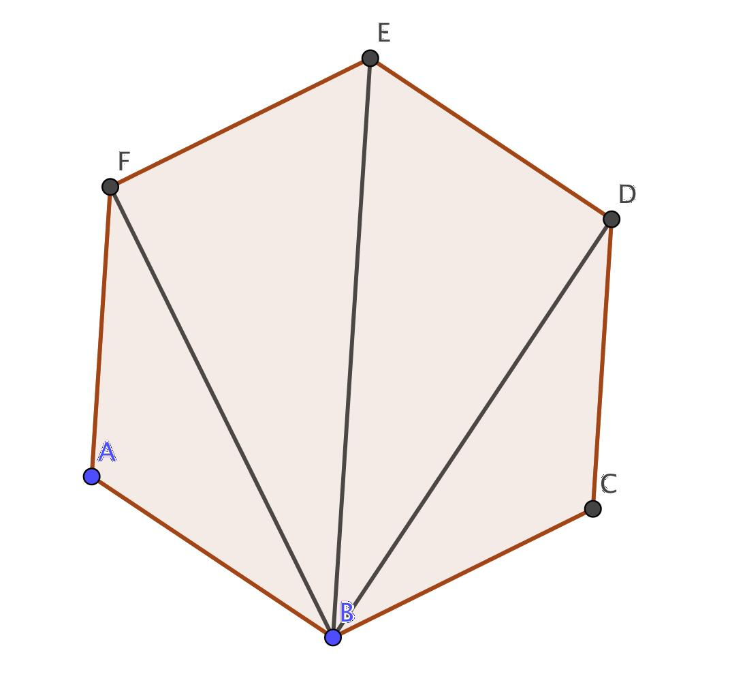
A hexagon can be divided into:
$$6-2=\boxed{4}$$
triangles using:
$$6-3=\boxed{3}$$
diagonals.

Triangulation of a Decagon
# Source: AI Source: Provided by: [Data Path: Persons Table -> ID Column: 1, Name_En Column: Motasem Essam] -> From: [ChatGPT] on [7/25/2026]
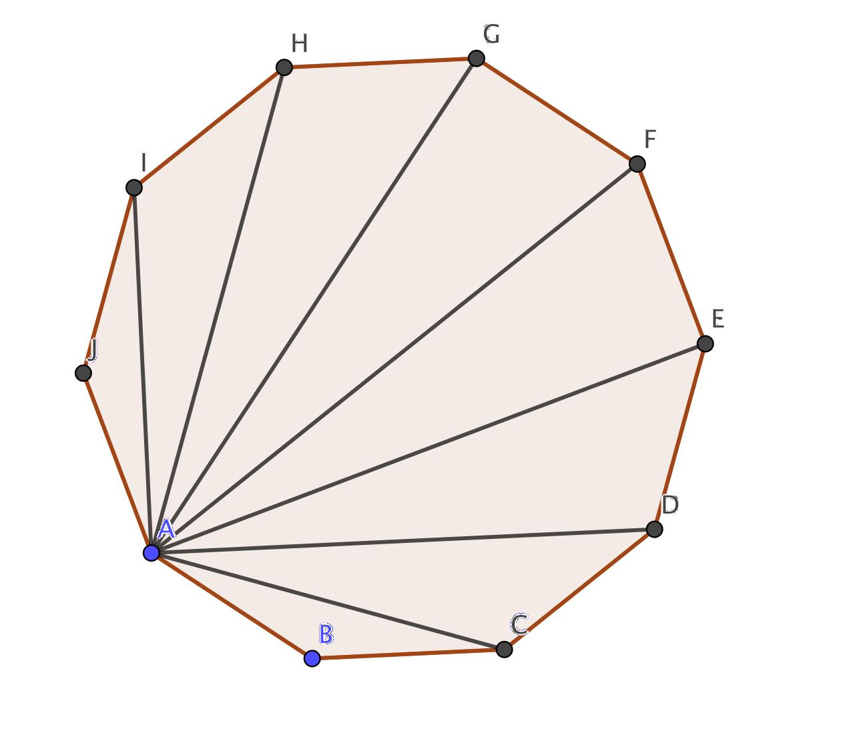
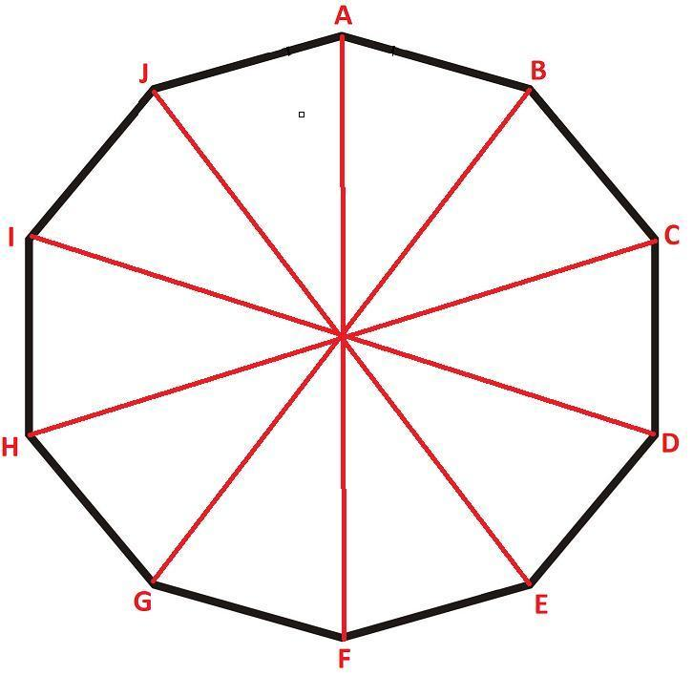
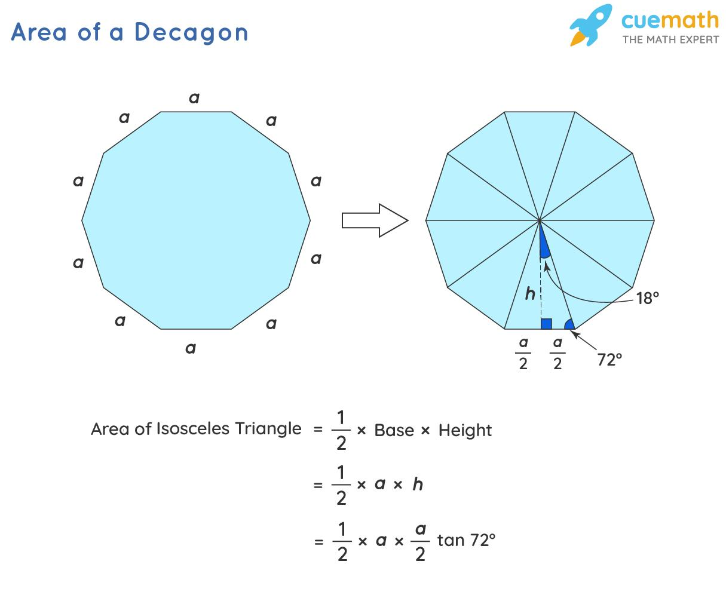
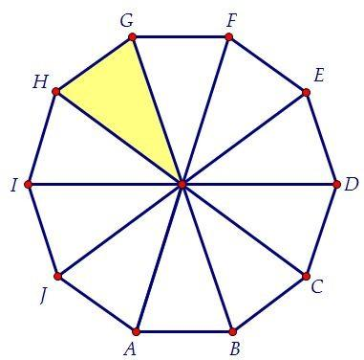
A decagon can be divided into:
$$10-2=\boxed{8}$$
triangles using:
$$10-3=\boxed{7}$$
non-crossing diagonals.
This is why the interior-angle sum of a decagon is:
$$8×{180}^{∘}=\boxed{{1440}^{∘}}$$

General Formula
# Source: AI Source: Provided by: [Data Path: Persons Table -> ID Column: 1, Name_En Column: Motasem Essam] -> From: [ChatGPT] on [7/25/2026]
For a polygon with $n$sides:
Number of triangles
$$\boxed{T=n-2}$$
Number of diagonals in one triangulation
$$\boxed{D=n-3}$$
Interior-Angle Sum
Since every triangle has ${180}^{∘}$:
$$\boxed{S=\left(n-2\right)×{180}^{∘}}$$
Thus, triangulation provides a geometric explanation for the polygon interior-angle-sum formula.

Example
# Source: AI Source: Provided by: [Data Path: Persons Table -> ID Column: 1, Name_En Column: Motasem Essam] -> From: [ChatGPT] on [7/25/2026]
Consider an octagon.
An octagon has:
$$n=8$$
Therefore:
Number of triangles
$$T=8-2 \\ \boxed{T=6}$$
Number of diagonals used
$$D=8-3 \\ \boxed{D=5}$$
Interior-angle sum
$$S=6×{180}^{∘} \\ \boxed{S={1080}^{∘}}$$
So:
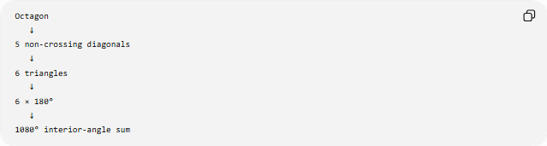
Octagon
↓
5 non-crossing diagonals
↓
6 triangles
↓
6 × 180°
↓
1080° interior-angle sum

Types of Triangulations

Fan Triangulation
# Source: AI Source: Provided by: [Data Path: Persons Table -> ID Column: 1, Name_En Column: Motasem Essam] -> From: [ChatGPT] on [7/25/2026]
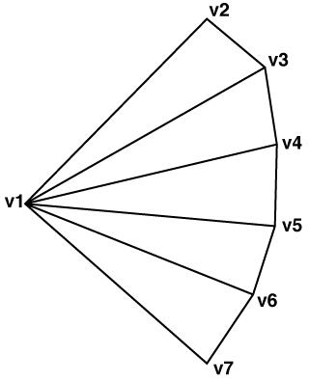
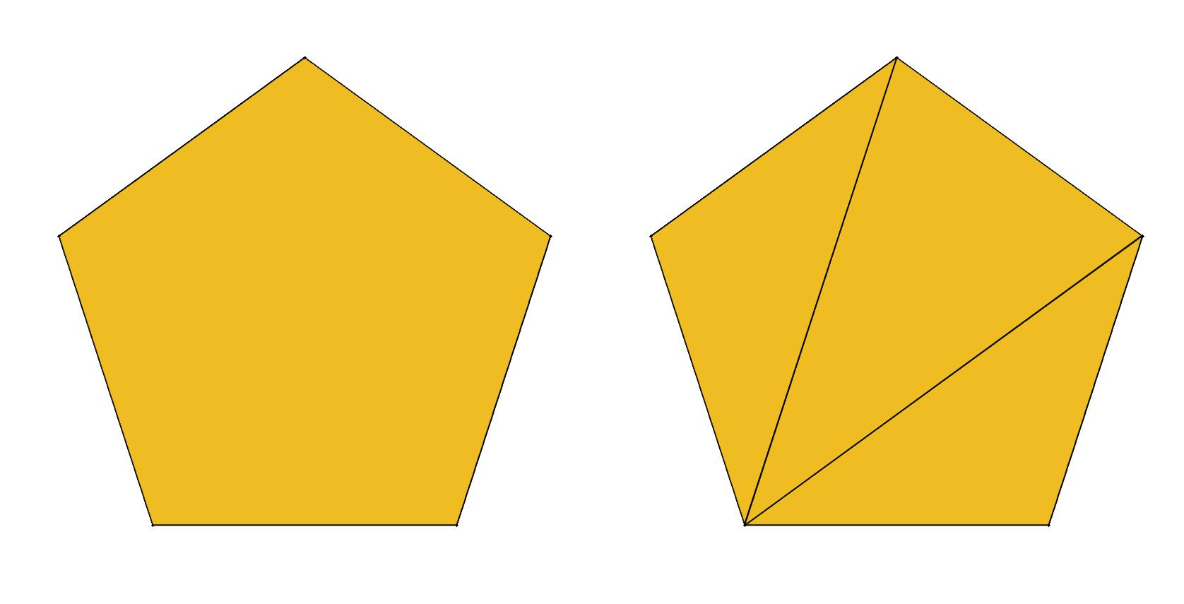
A fan triangulation is formed by choosing one vertex and connecting it to all non-adjacent vertices.
For an $n$-gon, the selected vertex connects to:
$$n-3$$
other vertices.
This produces:
$$n-2$$
triangles.

Ear Triangulation
# Source: AI Source: Provided by: [Data Path: Persons Table -> ID Column: 1, Name_En Column: Motasem Essam] -> From: [ChatGPT] on [7/25/2026]
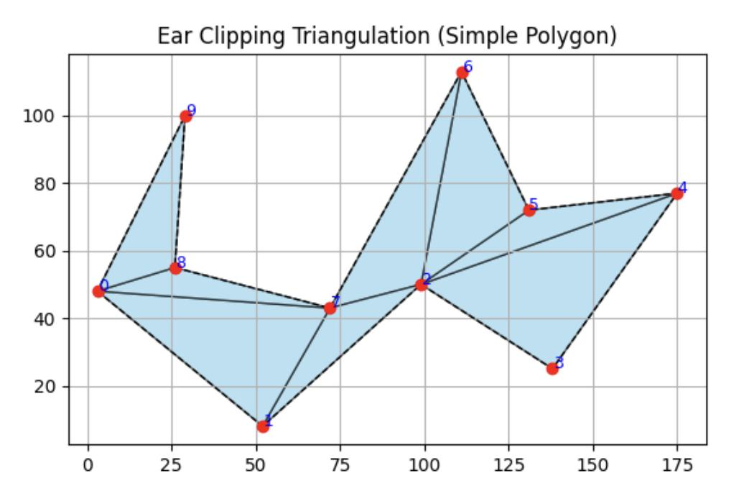
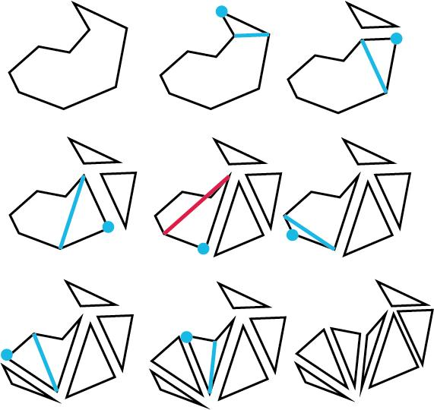
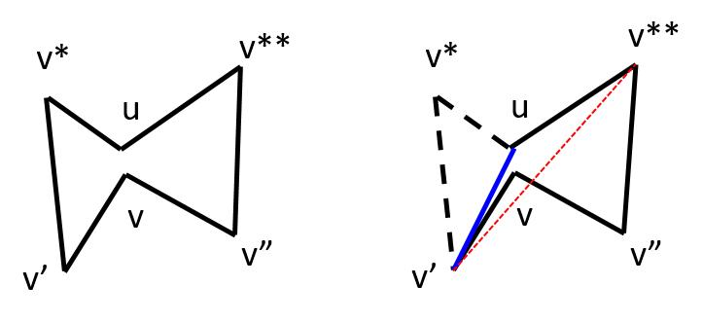
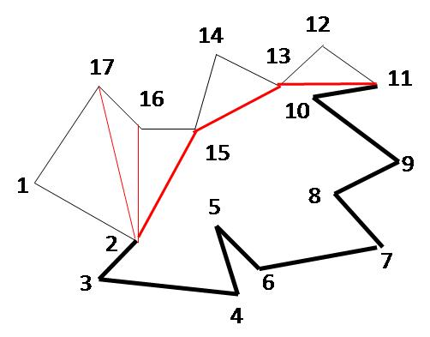
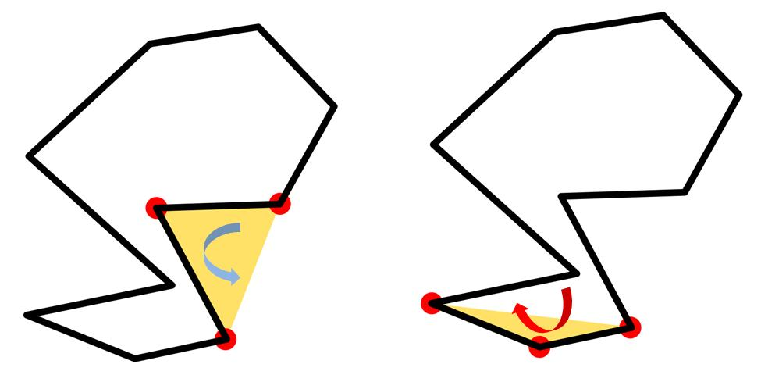
An ear is a triangle formed by three consecutive vertices of a polygon whose interior lies inside the polygon.
Ear triangulation repeatedly removes such triangles until only one triangle remains.
This method is especially important in computational geometry.

Convex Polygon Triangulation
# Source: AI Source: Provided by: [Data Path: Persons Table -> ID Column: 1, Name_En Column: Motasem Essam] -> From: [ChatGPT] on [7/25/2026]
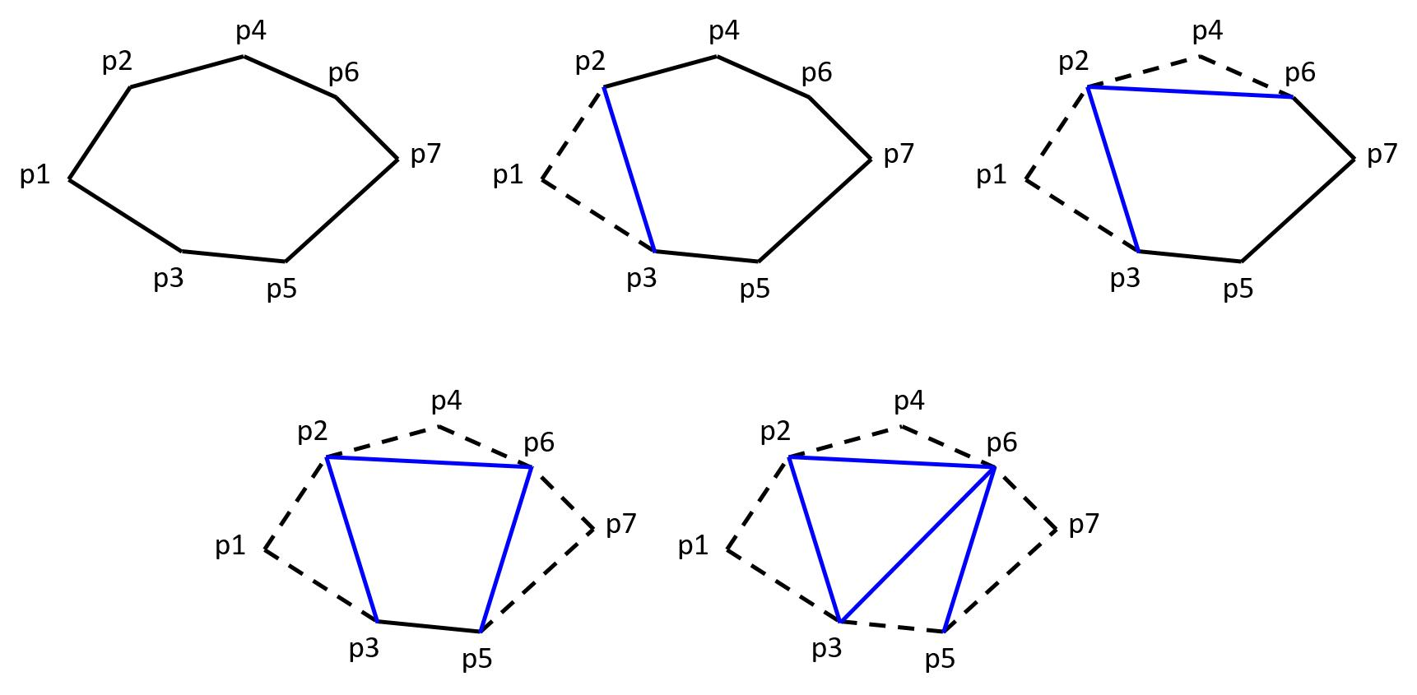
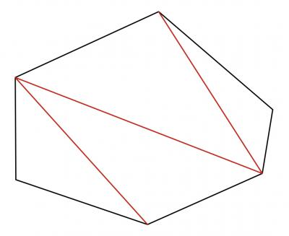
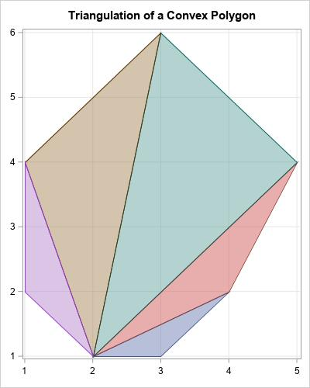
A convex polygon has a particularly simple triangulation.
Any diagonal connecting two non-adjacent vertices lies completely inside the polygon.
Therefore, a fan can be created from any vertex.
For an $n$-sided convex polygon:
$$\boxed{n-3\text{ diagonals}}$$
produce:
$$\boxed{n-2\text{ triangles}}$$

Concave Polygon Triangulation
# Source: AI Source: Provided by: [Data Path: Persons Table -> ID Column: 1, Name_En Column: Motasem Essam] -> From: [ChatGPT] on [7/25/2026]
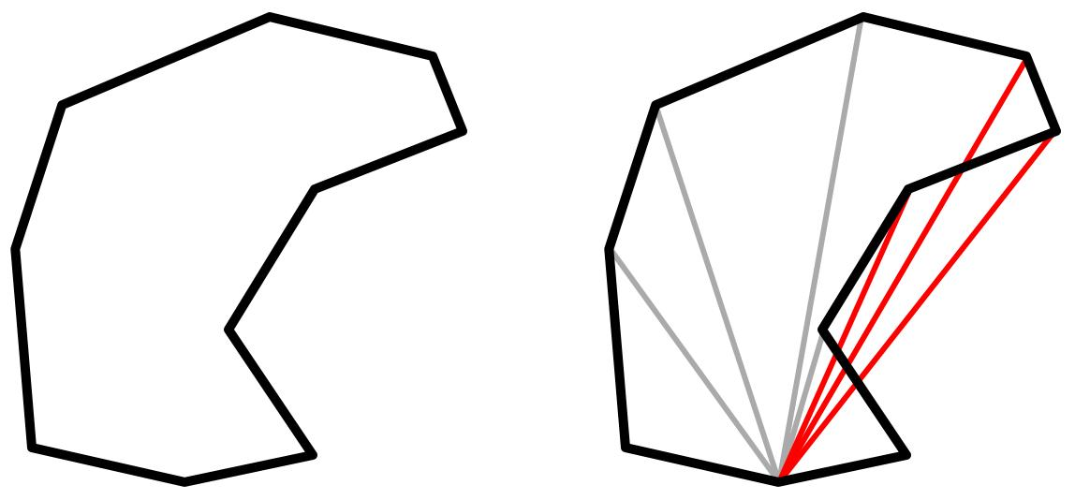
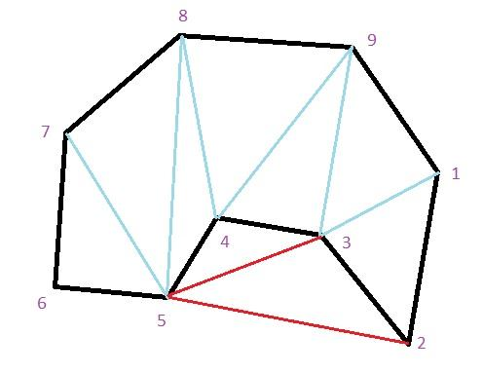
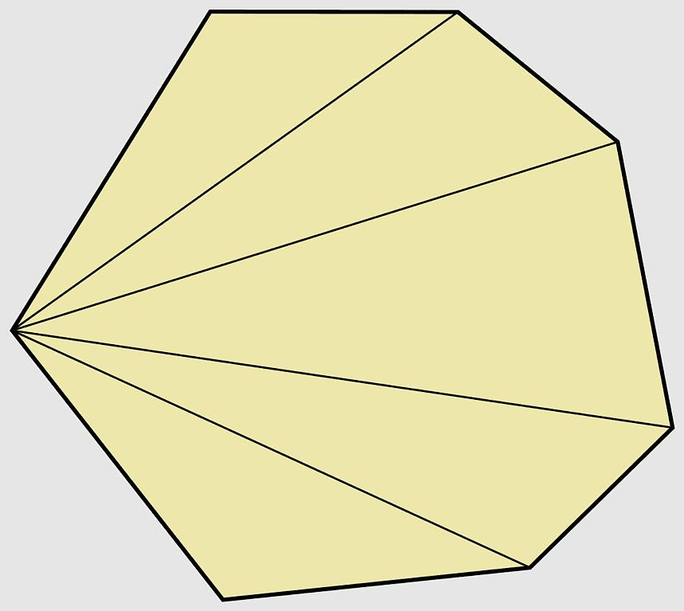
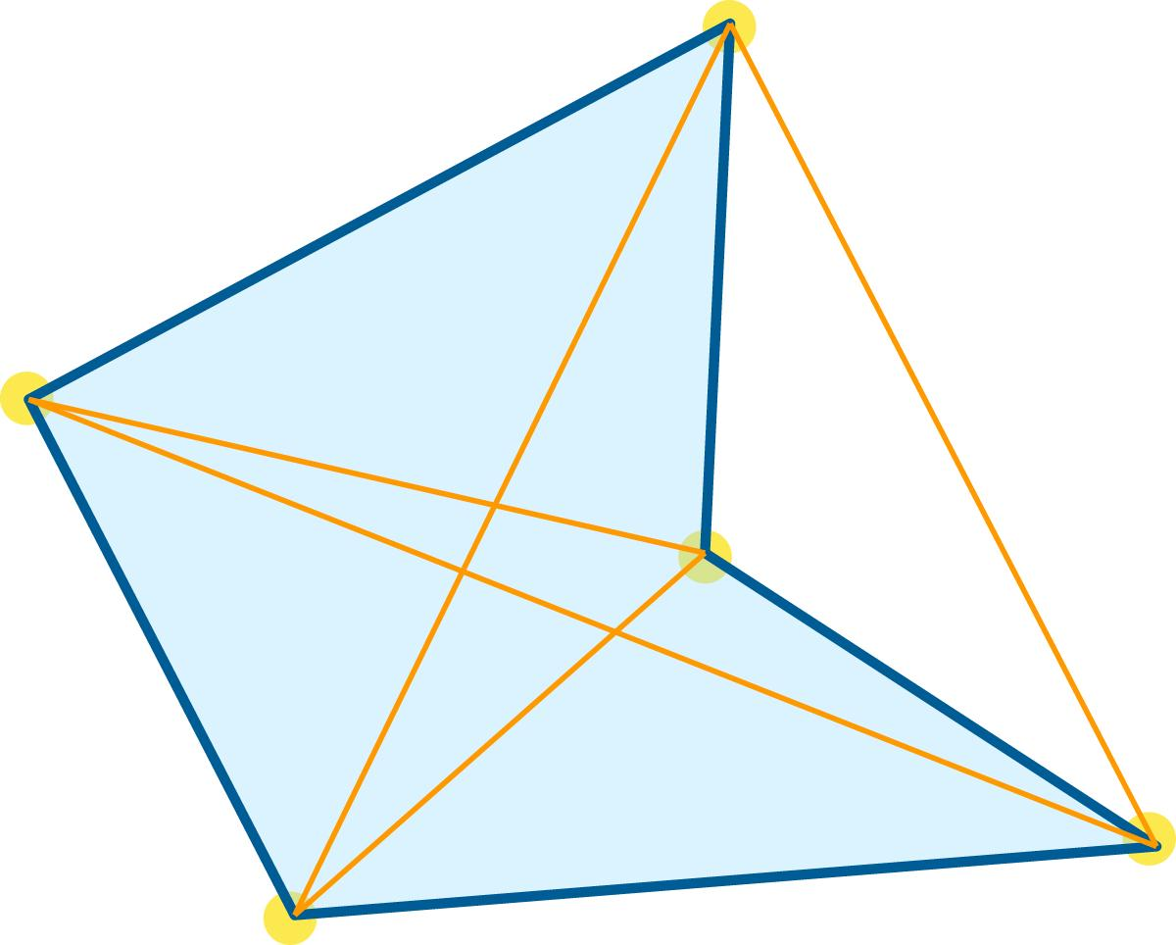
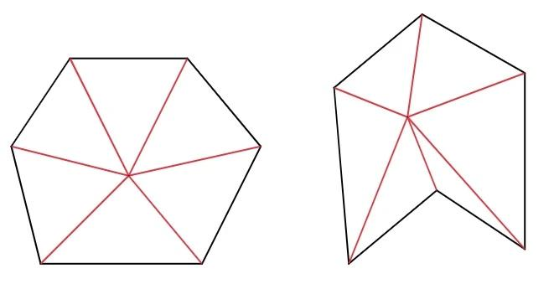
A concave polygon can also be triangulated, but not every diagonal lies inside the polygon.
Therefore, the selected diagonals must remain inside the polygon and must not cross each other except at common endpoints.
A simple concave $n$-gon still has:
$$\boxed{n-2}$$
triangles in every triangulation.

Properties of Triangulation
# Source: AI Source: Provided by: [Data Path: Persons Table -> ID Column: 1, Name_En Column: Motasem Essam] -> From: [ChatGPT] on [7/25/2026]
A triangulation of a simple polygon has these important properties:
- It divides the polygon into triangles.
- The triangles do not overlap in their interiors.
- The triangles completely cover the polygon.
- The diagonals do not cross except at shared vertices.
- An $n$-sided polygon produces exactly $n-2$triangles.
- Exactly $n-3$diagonals are required.
- The result depends on which valid diagonals are selected, but the number of triangles does not.

Triangulation and Polygon Area
# Source: AI Source: Provided by: [Data Path: Persons Table -> ID Column: 1, Name_En Column: Motasem Essam] -> From: [ChatGPT] on [7/25/2026]
Triangulation provides a way to calculate the area of an irregular polygon.
If a polygon is divided into triangles:
$$\boxed{A_{\text{polygon}}=A_{1}+A_{2}+⋯+A_{n-2}}$$
For each triangle:
$$A=\frac{1}{2}bh$$
Therefore, the polygon's area can be found by calculating and adding the areas of its triangles.

Triangulation and Interior Angles
# Source: AI Source: Provided by: [Data Path: Persons Table -> ID Column: 1, Name_En Column: Motasem Essam] -> From: [ChatGPT] on [7/25/2026]
Triangulation explains why the interior-angle sum of an $n$-gon is:
$$\boxed{\left(n-2\right){180}^{∘}}$$
Because the polygon is divided into $n-2$triangles, and every triangle contributes:
$${180}^{∘}$$
Thus:
$$\left(n-2\right)×{180}^{∘}$$
is the total interior-angle sum.

Triangulation vs. Diagonal Count
# Source: AI Source: Provided by: [Data Path: Persons Table -> ID Column: 1, Name_En Column: Motasem Essam] -> From: [ChatGPT] on [7/25/2026]
These two concepts should be distinguished:
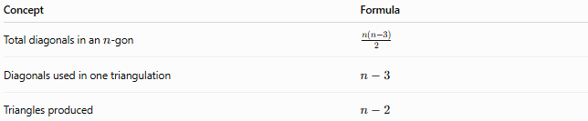
Concept | Formula
Total diagonals in an $n$-gon | $$\frac{n\left(n-3\right)}{2}$$
Diagonals used in one triangulation | $$n-3$$
Triangles produced | $$n-2$$
For example, a decagon has 35 total possible diagonals, but only 7 diagonals are needed for one triangulation.

Applications
# Source: AI Source: Provided by: [Data Path: Persons Table -> ID Column: 1, Name_En Column: Motasem Essam] -> From: [ChatGPT] on [7/25/2026]
Triangulation is widely used in:
- Geometry
- Trigonometry
- Calculus
- Computer graphics
- Computational geometry
- 3D modeling
- Computer-aided design (CAD)
- Geographic information systems (GIS)
- Finite-element analysis
- Architecture
- Engineering
- Game development
In computer graphics, complex surfaces are frequently represented as collections of triangles because triangles are simple and always planar.

Relationship to Polygons
# Source: AI Source: Provided by: [Data Path: Persons Table -> ID Column: 1, Name_En Column: Motasem Essam] -> From: [ChatGPT] on [7/25/2026]
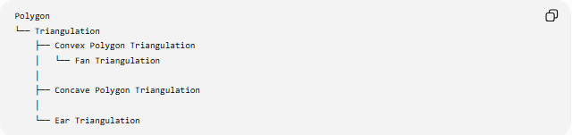
Polygon
└── Triangulation
├── Convex Polygon Triangulation
│ └── Fan Triangulation
│
├── Concave Polygon Triangulation
│
└── Ear Triangulation
Triangulation is therefore not a type of polygon. It is a process or decomposition method applied to a polygon.

Key Points
# Source: AI Source: Provided by: [Data Path: Persons Table -> ID Column: 1, Name_En Column: Motasem Essam] -> From: [ChatGPT] on [7/25/2026]
- Triangulation divides a polygon into triangles.
- A simple $n$-gon always produces $n-2$triangles.
- A triangulation uses $n-3$diagonals.
- The diagonals must not cross except at common endpoints.
- Convex polygons are particularly easy to triangulate.
- Concave polygons require more careful diagonal selection.
- Triangulation can be used to calculate polygon areas.
- It explains the polygon interior-angle-sum formula.
- A polygon can have multiple different triangulations, but all valid triangulations contain the same number of triangles.
- The total number of diagonals is different from the number of diagonals used in one triangulation.

